**Drop-down list**

A **drop-down list** (abbreviated **drop-down;** also known as a **drop-down menu, drop menu, pull-down list, picklist)** is a graphical control element, similar to a **list box,** that allows the user to choose one value from a list.

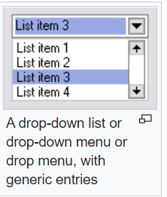

**Types of Drop-down List:**

* Select Tag
* ul.li (unordered List)
* div (Div Element)

**Sample Select Tag:**

**Code:**

<html>

<head>

<title> HTML Select Tag </title>

</head>

<body>

<h1> HTML Select Tag </h1>

<br>

<label For="Cars"> My FavoriteS </label>

<select name="MyCollections">

<option value="Audi">Audi</option>

<option value="Mercedes Benz">Mercedes Benz</option>

<option value="Royal Enfield">Royal Enfield</option>

<option value="Pulsar">Pulsar</option>

<option value="Gixer">Gixer</option>

</select>

</body>

</html>

**Output:**

# HTML Select Tag

My FavoriteS 

**Why we need Value Attribute in Select Tag:**

The **value attribute** specifies the **value** to be sent to a server when a form is submitted. The content between the opening **<option>** and closing **</option>** **tags** is what the browsers will display in a drop-down list. However, the **value** of the **value attribute** is what will be sent to the server when a form is submitted.

**Types of Attributes in Select Tag:**

|  |  |  |  |
| --- | --- | --- | --- |
| **S.No** | **Attribute** | **Value** | **Description** |
| 1 | autofocus | autofocus | Specifies that the drop-down list should automatically get focus when the page loads |
|  |  |  |  |
|  |  |  |  |
|  |  |  |  |